**Week-2: Product Vision & Goals -Applied to Case Studies**

**Group-2**

Devaki B, Keerthi A, Sri Lasya G, Harsha Priya C, Sanjeev Kumar B

Saint Louis University

IS-5960 – Master Research Project

Maria Weber

August 31, 2025

**Industry & Company Selection, Product Vision, and Prioritized Feature List**

**Case Study Selected:** University Alumni Connect

**Introduction**

In the evolving landscape of higher education, higher education institutions should strive to provide evident value to their students, alumni and employers. The involvement of the alumni and employment information is now part of the institution reputation enhancement, construction of industry relationships, and student success assurance rather than aiding. The case study of Saint Louis University (SLU) and the Alumni Connect Initiative aims to overcome the current issues of tracking, engagement, and employer-related collaboration of the alumni by using high-level analytics and technology. This assignment will detail the industry and institutional scene, product vision, strategic goals and a prioritized list of features so that the initiative can do the best.

**1. Industry Selection**

**Industry:** Higher Education & Educational Technology (EdTech)

Data analytics, digital platforms and alumni networking technologies are leading to rapid transformation in the higher education industry. Universities are turning to EdTech solutions as a solution to show students return on investment (ROI), support alumni relationships, and establish relationships with employers. Key trends include:

* Increasing the adoption of data analytics to quantify alumni career outcomes.
* Higher demand of mentorship platforms between students and graduates.
* Increasing competition between universities in terms of global rankings, funding, and image.

This industry is important since the involvement of alumni does not only contribute to the reputation of the university but also gives insights in curriculum design, fundraising, and career provision.

**2. Company Selection**

**Institution:** Saint Louis University (SLU) – Alumni Connect Initiative

SLU is a large privately research university with diversified alumni network in different industries across the globe. Although the institution is well represented academically, it is struggling with the problem of tracking of the employment of its alumni, gauging of the engagement, and the utilization of the relation of alumni and employers. The Alumni Connect program is an attempt to fill these gaps by creating a centralized analytics system.

* Size & Scope: Large-scale university with global alumni network.
* Market Position: Compete in the field of higher education, seek to empower alumni participation and career results in a digitalized way.

**3. Product Vision Statement**

“To create a data-driven alumni-engagement and analytics platform that links SLU graduates to students, faculty, and employers to facilitate mentorship, networking and real-time career insights to reinforce student outcomes and institutional reputation”.

**4. Goals**

Image source: <https://blogs.iu.edu/earlychildhoodinsights/2025/01/14/writing-smart-goals/>

1. **Increase alumni engagement** through monitoring and improving participation of alumni in university events, mentorship and donations within the initial year of platform implementation.
2. **Improve student-employer connections** by enabling alumni-led referrals, networking, and posting jobs on the platform during the initial rollout of the platform.
3. **Build a centralized alumni data repository** of alumni data which combines survey data, LinkedIn data, and university data to give accurate employment indications by the completion of the initial implementation cycle.
4. **Establish new employer partnerships** with the help of alumni career knowledge to reinforce internship pipelines, collaborative research, and recruitment possibilities in the first year of study.
5. **Provide leadership with interactive dashboards** to provide the leadership with real-time reports of alumni engagement and employment outcomes, which allows the administration to make evidence-based decisions by six months of launch.

**5. Prioritized Feature List**

**Prioritization Method Chosen:** **MoSCoW (Must-Have, Should-Have, Could-Have, Won’t-Have)  
Reason for Selection:** MoSCoW makes a clear distinction between mandatory features and ones that can be added to an MVP (Minimum Viable Product) later. The fact that there are several stakeholders (students, alumni, employers, faculty) makes this method the one that will keep the immediate needs in line with what is needed in the future.

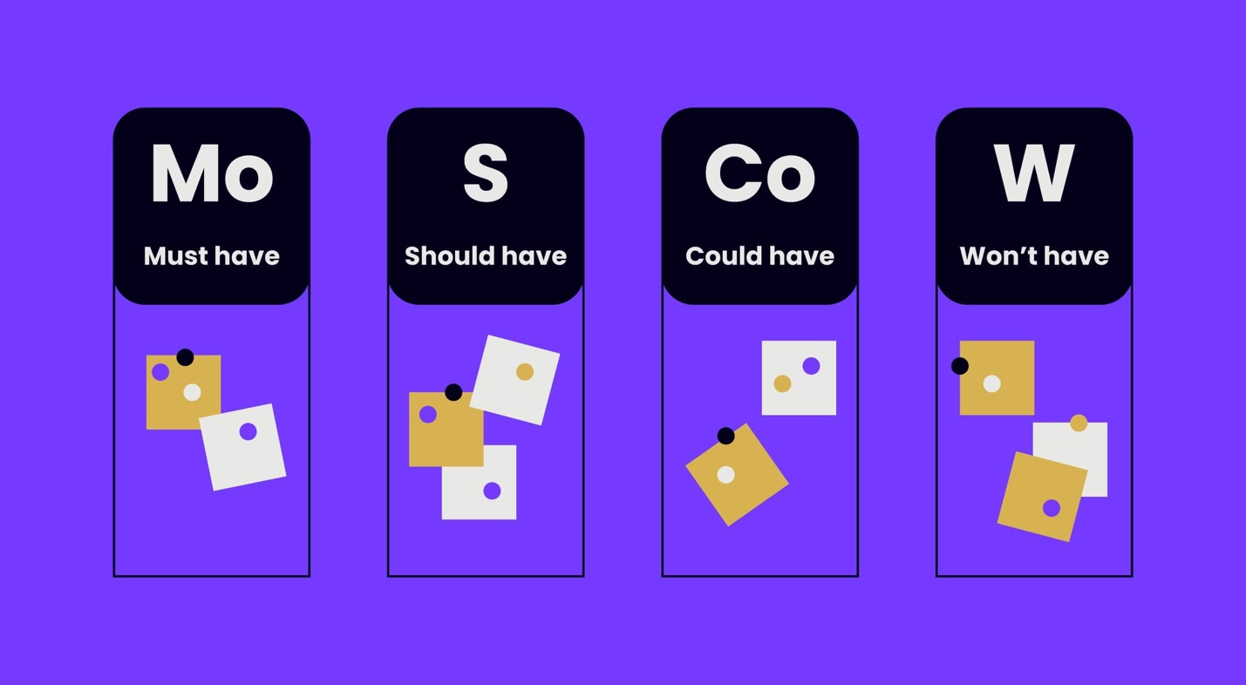

Image source: <https://windmill.digital/great-mvp-feature-prioritization-methods/>

**Feature Prioritization (MoSCoW)**

**Must-Have (Critical for MVP)**

* **Alumni Employment Dashboard**: Visualize employability of alumni by company, industry and skills, and geography with Tableau.
* **Alumni-Student Mentorship Matching**: Pair the students with the alumni mentors depending on the branch, skills and career objectives.
* **Employer Insights Dashboard**: Provide analytics on top recruiters, industries, and in-demand skills.
* **Secure Data Integration Pipelines**: Python ETL with MySQL to gather LinkedIn, survey and SLU data.

**Should-Have (Important, Next Phase)**

* **Alumni Engagement Scoring System**: Monitor contributions (mentorship, donations, events) to ascertain the level of the activity of alumni.
* **Event Management & Tracking**: Allow alumni and students to sign up, attend and give feedback to events.
* **Personalized Alumni Recommendations**: AI-driven suggestions for networking and mentorship connections.

**Could-Have (Future Enhancements)**

* **Gamification Features**: Introduce badges, leaderboards, and recognition for active alumni contributors.
* **Mobile App Version**: Build an Alumni Connect mobile-friendly application to enable bigger access.
* **Job Board Integrations**: Get linked with platforms such as Indeed and Glassdoor and reach more opportunities.

**Won’t-Have (Initial Scope, Future Roadmap)**

* **AI Chatbot for Career Counseling**: Intelligent assistant for alumni-student guidance (future roadmap).
* **Blockchain Credential Verification**: Trustworthy alumni degree confirmation to employers (future study).

|  |  |  |  |
| --- | --- | --- | --- |
| **MoSCoW Method** | | | |
| **Feature** | **Category** | **Description** | **Tech Stack** |
| Alumni Employment Dashboard | Must-Have | Visualize alumni employment by company, industry, role, and geography | Tableau + MySQL + Python ETL |
| Alumni-Student Mentorship Matching | Must-Have | Connect students with alumni mentors based on career goals and skills | React + MySQL |
| Employer Insights Dashboard | Must-Have | Track top recruiters, industries, and skills in demand | Tableau + Python ETL |
| Secure Alumni Data Integration | Must-Have | Collect and process alumni data from LinkedIn, surveys, and SLU systems | Python ETL + MySQL |
| Alumni Engagement Scoring | Should-Have | Measure alumni activity (mentorship, events, donations) | Tableau + MySQL |
| Event Management & Tracking | Should-Have | Manage alumni participation in events and workshops | React + MySQL |
| Personalized Alumni Recommendations | Should-Have | Suggest networking and mentorship matches | Python + React |
| Gamification Features | Could-Have | Badges, leaderboards, and recognition for active alumni | React + MySQL |
| Mobile App Version | Could-Have | Cross-platform mobile access to alumni platform | React Native |
| Job Board Integration | Could-Have | Integrate with external platforms (Indeed, Glassdoor) | Python APIs |
| AI Chatbot for Career Counseling | Won’t-Have | AI assistant for alumni-student guidance (future roadmap) | NLP + AI Models |
| Blockchain Credential Verification | Won’t-Have | Secure alumni degree validation (future roadmap) | Blockchain |

**Final Solution**

The proposed solution is a s a centralized Alumni Engagement and Analytics Platform that is created based on the chosen technology stack of SLU (MySQL, Python ETL, Tableau, React, and GitHub/OneDrive to collaborate). The platform will:

* Provide real-time dashboards for employment outcomes and employer partnerships.
* Facilitate alumni-undergraduate mentorship that is equivalent to enhance career preparedness.
* Measure and advance alumni engagement using event tracking systems and scoring systems.
* Facilitate strategic employer alliances through finding the best recruiters and skill gaps.
* Have data security and compliance and be able to scale in the future.

This solution balances short-term deliverables (MVP dashboards and mentorship tools) with long-term opportunities (AI networking, mobile apps, blockchain credentialing).

**Predictions**

Based on the proposed solution and its implementation, the following outcomes are anticipated:

1. **Stronger Alumni Engagement** – Personalized tracking of engagement will increase personalized involvement of alumni in mentorship, events and donations.
2. **Improved Student Career Outcomes** – Students will have access to alumni-led referrals, industry knowledge and better pipelines to employers.
3. **Enhanced Employer Partnerships** – Universities will attract more employer relationships through alumni success and by designing programs to fit industry demands.
4. **Data-Driven Decision Making** – SLU leadership will have the ability to make real-time analytics to inform academic planning, fundraising, and global positioning.
5. **Sustainable Growth** – The platform will develop a scalable approach which can be extended to sophisticated capabilities including AI networking suggestions and blockchain-based verification of alumni credentials.

**Conclusion**

University Alumni connect initiative places SLU on the leading edge of alumni engagement and employability analytics based on data. The platform addresses the key strategic business areas of visibility of the employment, mentorships between alumni and students, and employer insights, which directly align with the mission of SLU, which is education, connection, and empowerment of its global community. This initiative offers a scalable and sustainable solution through smart prioritizing of features and adjusting it to institutional strategy that can change with student needs, alumni need, and employer needs.